(Approx. 484 words)

Stranded Alaskan Snowmobiler Saved By iPhone's Emergency SOS Via Satellite Feature
By Kurt Jefferson, Editor, Central Kentucky Computer Society
https://ckcs.org/
lextown2 ** gmail.com

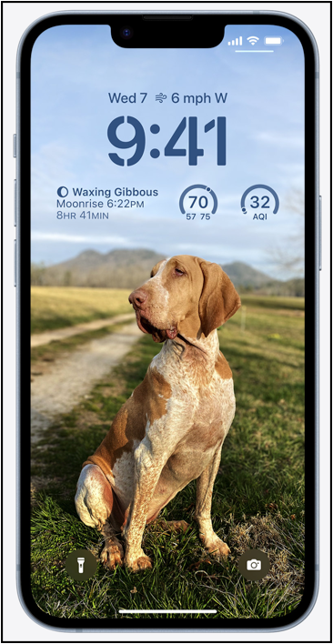
In early December, the Alaska Department of Public Safety issued a brief report about a man stranded on a snowmobile in a remote part of the state.

The man pulled out his iPhone 14 and used the Emergency SOS via Satellite feature to call for help. The Emergency SOS via Satellite service is automatically triggered on all iPhone 14 models when an attempt is made to call 911, and cell service or Wi-Fi is unavailable.

This was apparently the first time the iPhone's satellite phone feature was used to rescue a stranded individual.

From the Alaska Department of Public Safety report (according to 9to5Mac):
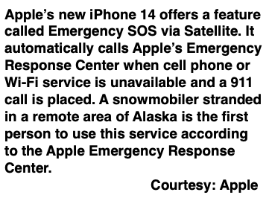
"On December 1, 2022, at around 2:00 am, the Alaska State Troopers were notified that an adult male traveling via snowmachine from Noorvik to Kotzebue had activated an Apple iPhone Emergency SOS via satellite on his iPhone after becoming stranded. Working with local search and rescue teams, the Apple Emergency Response Center, and the Northwest Arctic Borough Search and Rescue Coordinator, the NWAB SAR deployed four volunteer searchers to the Nimiuk Point area directly to the GPS coordinates provided by the Apple Emergency Response Center. The adult male was located and transported to Kotzebue by the volunteer search team. There were no injuries reported to Troopers."

MacRumors reports: "Apple's Emergency Response Center worked with local search and rescue teams and the Northwest Arctic Borough Search and Rescue Coordinator to send out volunteer searchers directly to the GPS coordinates relayed to Apple using the emergency function. The man was rescued successfully, and there were no injuries. However, the area where he was located is remote and on the fringes of where satellite connectivity is available. Apple says satellite connectivity might not work in places above 62° latitude, such as northern parts of Canada and Alaska, and Noorvik and Kotzebue are close to 69° latitude."

Business Insider reports authorities located the man at Nimiuk Point and was taken to Kotzebue by the rescue team at 6 am 9to5Mac writes the emergency satellite service is available in iPhone 14 models because of a new radio chip included in those phones.

Garmin, a long–time maker of smartwatches and exercise apps, launched a similar service in 2011 called inReach Messenger.

As of October 2022, Garmin reported that its emergency service had helped 10,000 people who needed immediate assistance.

Garmin says its service is often used to help other folks who don't own the device make the emergency call. In addition, Garmin lists the top five reasons people have used its emergency service over the past eleven years:

1. Injury
2. Medical issue
3. Vehicle accident
4. Stranded/Stuck
5. A vehicle problem

The top five incidents requesting emergency help from Garmin:

1. Hiking/Backpacking
2. Driving
3. Motorcycling
4. Climbing/Mountain climbing
5. Boating

